The Program includes a framework and several algorithms.

# Interface

The interface is finished using JAVA Swing. The main interface is a JFrame.

## MainFrame

MainFrame is a subclass of JFrame. It shows some tab panels and a status bar as shown in Figure 1.

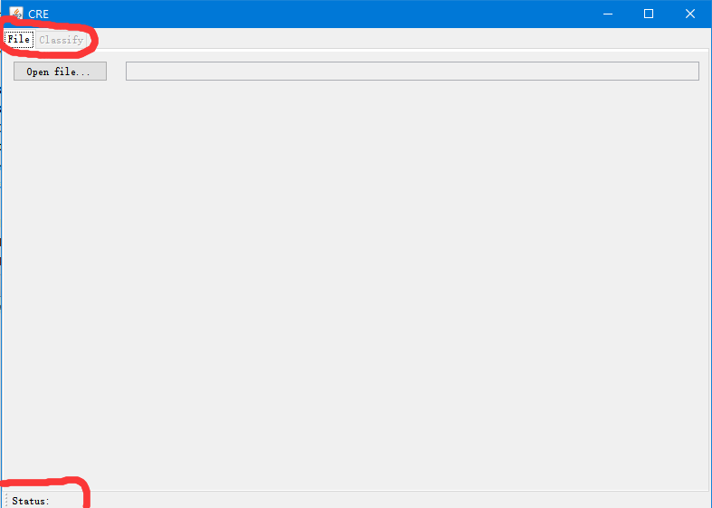

Figure 1 MainFrame

MainFrame implements some interfaces like MainFrameEventHandler and CanShowStatus. The former limits the access from other Class. The latter makes MainFrame to be a “Show Status Provider”.

## FilePanel

Until now, FilePanel has only one function, choose a file. When user chooses a file, this class inform the MainFrameEventHandler(actually MainFrame) by calling its function selectANewFile(File).

Notice: user may choose a file repeatly even when one algorithm is calculating.

## ClassifyPanel

When user chooses a file in FilePanel, ClassifyPanel becomes available. This panel consisits of three parts. North is the section in which user can choose an algorithm and configure the algorithm. West is the section which has “start button” and “stop button” and shows history of each transaction. When we change the item in history, the center part, a JTextArea will show the outputs.

# How to integrate an algorithm

An algorithm must extend “AbstractAlgorithm”. An algorithm must have some configurations, like a threshold. We store these configuration in a class. And this class will be the member of the algorithm.

First, we need to create a class as the map of configuration.

Second, we need to create a class which extends AbstractAlgorithm.

Finally, modify some lines in ClassifyPanel.

## How to write the class as the map of configuration

The class should implement Cloneable interface. Because when user start a calculation, the algorithm which is used is only a copy of the original algorithm and the original algorithm may be modified when calculation is still going. The class as the map of configuration is part of the algorithm, as Figure 2.

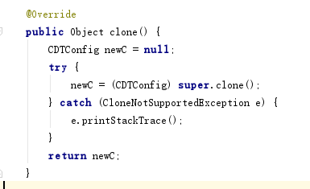

Figure 2 the “configuration class”

The class should override “toString”. This function is called when show the configuration.

The types which configuration can use and extra functions are shown below. These attributes must have setters and getters. Assume the name of attribute is XXX. Each attributes may have function “String getXXXComments()” to provide the comment of the attribute..

|  |  |  |  |
| --- | --- | --- | --- |
| Data Type | View (Corresponding to the attribute and created automatically) | functions | remark |
| int | JTextField | int getXXXMax() | return the maximal value of XXX |
| int getXXXMin() | return the minimum value of XXX |
| double | JTextField | double getXXXMax() | Return the maximal value of XXX |
| double getXXXMin() | return the minimum value of XXX |
| boolean | JCombobox(only true or false) |  |  |
| String | JTextField or JCombobox | String[] getXXXList() | If this function exists, it means user need to pick a String from a list and there will be a JCombobox instead of a JTextField. |
| TreeMap<String, List<Integer>> | JTextField(User can not edit this JTextField. But A dialog will appear when user clicks the JTextField) | String[] getXXXNames() | To divide “names” into several categories.  For example. “Tina Bob Tom Helen” is the returned value from “getXXXNames” while “Male Female” is the returned value from “getXXXClasses”. When user click the JTextField, a Dialog will show as shown in Figure 3. The value of TreeMap will be “[“Male”:[1, 2], “Female”: [0,3]]”. |
| String[] getXXXClasses() |

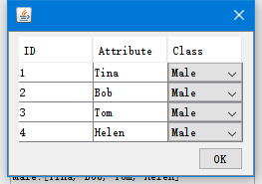

Figure 3

Class “ConfigSample” is a sample.